JOB DESCRIPTION
Job Title | Personal Banker | Location | Byblos Bank Syria SA
Code: |  | Edition | 1
Division | Consumer Banking | Department | Branch
Effective Date |  | Revised Date | Aug 2011
Employee Name |  | Starting Date

1- JOB PURPOSE
Responsible for promoting, developing, and managing the Bank’s retail business on daily basis. Perform all non-cash transactions and sustain relationship with clients based on full understanding of the business and banking needs.

2- LINES OF REPORTING
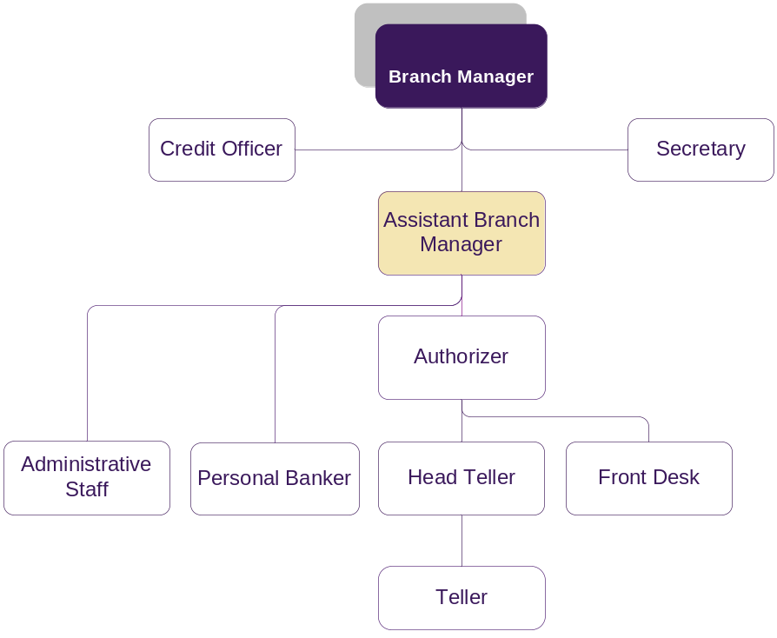

3- ORGANISATION RELATIONSHIP
Byblos Bank Syria:
- Branch Manager.
- Assistant Branch Manager.
- Authorizer.

Byblos Bank Lebanon:
- Consumer Banking Division Lebanon

4- DUTIES & RESPONSIBILITIES
Handling Client’s accounts and requests duties & responsibilities

- Execute all non-cash transactions to clients and ensure accuracy of documents and signatures.
- Collect information required and ensure existence and accuracy of all required documentation according to the standard checklist.
- Receive and verify client requests for Trade finance , Letters of Guarantee.
- Create and amend customer information file.
- Open and close customers’ accounts and handle customer request for amendments.
- Handle customers’ accounts and loan inquiries.
- Deliver mail and account statements to clients upon their request.
Promoting and developing the bank’s products & services duties & responsibilities

- Promote the Bank’s products inside and outside the branch according to a plan predefined with the Branch Manager.
- Post and update the branch client database with a customer information file for potential customers.
- Report to the Branch Manager/Assistant Branch Manager any pertinent information that should be escalated to the Compliance Officer in Lebanon.
- Generate and control End of day reports as required per control procedure.
- Follow-up with clients on all pending issues in order to complete their retail files.
- Ensure proper customer signature on all retail documents.

- Other duties and responsibilities as assigned.

5- JOB REQUIREMENTS
- Education Level:
Technical or Bachelor degree in accounting or finance

- Experience :
1 to 2 years of relevant experience.

- Required Competencies:
Technical:
- Ability to produce work effectively and efficiently (Quality Service).
- Ability to organize work effectively and efficiently (Organizational Abilities).
- Ability to effectively explore alternatives that reach outcomes, gains the support and acceptance of all parties, and builds mutual agreement (Negotiation Skills).
- Ability to identify, anticipate and respond to customer requirements effectively and profitably (Marketing Skills).
- The ability to identify the Banks Products and their respective operational process (Products Knowledge).
- Ability to understand all Banking Operations, identify the related risks and audit ongoing operations. (Operations Control).
- Ability to identify the conditions of each type of credit and extend to the compliant client the right credit (Credit Management).
- Ability to fill applications, detects errors in filled ones, handle operations, respond to clients’ queries, and analyze risk (Trade Finance).
- Ability to understand Banking Operations and their respective policies and procedures (Banking Operations).

Behavioral:
- Ability to identify, meet and exceed internal and external customer expectations (Customer Service).
- Ability to work co-operatively and productively with other members of them team in order to achieve common goals (Teamwork).
- Ability to respond to changing situations by continually improving his/her performance by learning and development (Self Management).
- Ability to develop and maintain win/win relationships and partnerships (Relationship Building).
- Ability and willingness to abide by and respect all the policies and procedures of Byblos bank (Organizational Awareness).
- Ability and willingness to effectively work in, and adapt to change (Flexibility and Adaptability).
- Ability to know what results are important while focusing on resources to achieve the corporate goals (Results Orientation).
- Ability to clearly convey and receive messages to meet the needs of others by listening, interpreting and delivering: Oral, written and/or electronic messages (Communication Skills).

Technical | Behavioral | Managerial | Leadership
Quality Service  TQUS001  4/4  Level | Customer Service  BCUS002  4/4  Level
Organizational Abilities  TORA005  3/4  Level | Teamwork  BTEA003  2/4  Level
Negotiation Skills  TNES008  2/4  Level | Self Management  BSEM004  2/4  Level
Marketing Skills  TMAS002  2/4  Level | Relationship Building  BREB006  Level  2/4
Product Knowledge  TGLS027  2/4  Level | Organizational Awareness  BORA008  2/4  Level
Operations Control  TGLS028  1/4  Level | Flexibility and Adaptability  BFLA009  3/4  Level
Credit Management  TGLS030  2/4  Level | Results Orientation  BREO010  2/4  Level
Trade Finance  TGLS031  1/4  Level | Communication Skills  BCOS001  4/4  Level:
Banking Operations
TGLS029
2/4
Level

6- WORKING CONDITIONS
  - Environmental Conditions:
The job is largely desk based accordingly it does not require significant physical effort and does not expose the job holder to any significant environmental threats.

  - Physical Conditions:
The job holder will work in a relatively high pressure environment that requires adherence to various deadlines and the ability to withstand stress.

7- MATERIALS USED
- Tools used in this occupation:
- Computer equipment
- Office
- Telephone

- Technology used in this occupation:
- Office suite software
- Spreadsheet software (e.g. Microsoft Excel)
- Word processing software (e.g. Microsoft Word)
- Electronic Mail Software (e.g. Microsoft Outlook)
- Temenos (Globus T24) System

I affirm having received, read and understood my Job Description.

Employee Name / Signature & Date

Direct Supervisor Name / Signature & Date

